Student Name: Gautam Gupta
Student ID: 11802547
GitHub Link: https://github.com/gautam-ssdn/11802547-OS-CA-2-

Problem:
Researchers designed one system that classified interactive and noninteractive processes automatically by looking at the amount of terminal I/O. If a process did not input or output to the terminal in a 1-second interval, the process was classified as noninteractive and was moved to a lower-priority queue. In response to this policy, one programmer modified his programs to write an arbitrary character to the terminal at regular intervals of less than 1 second. The system gave his programs a high priority, even though the terminal output was completely meaningless.
Explanation:
- Input the number of processes.
- Enter the response time for each process.
- On the basis of response time of a process it is differentiated as INTERACTIVE and NON-INTERACTIVE process.
- If response time is less than 1 second then it comes under INTERACTIVE processes.
- If response time is 1 second or greater than 1 second then it comes under NON-INTERACTIVE processes.
Code Snippet:
#include<stdio.h>
int main()
{
int i, type[20],n;
int respT[20];

printf("Number of processes:\n ");
scanf("%d",&n);
printf("Enter the data for the processes\n");
for(i=0;i<n;i++)
{
printf("Response time of Process %d (in milliseconds):\n ",i+1);
scanf("%d",&respT[i]);
if(respT<0)
{printf(“Time entered is not valid.”);}
else
{
if(respT[i]<1000)
{
type[i]=1;
}
else
{
type[i]=0;
}
}
}
printf("Process Number\tResponse Time\tType\t\tPriority");
for(i=0;i<n;i++)
{
printf("\nP%d\t\t%dms\t\t",i,respT[i]);
if(type[i]==1)
{
printf("Interactive\tHigh");
}
else
{
printf("Non-Interactive\tLow");
}

}
return 0;
}
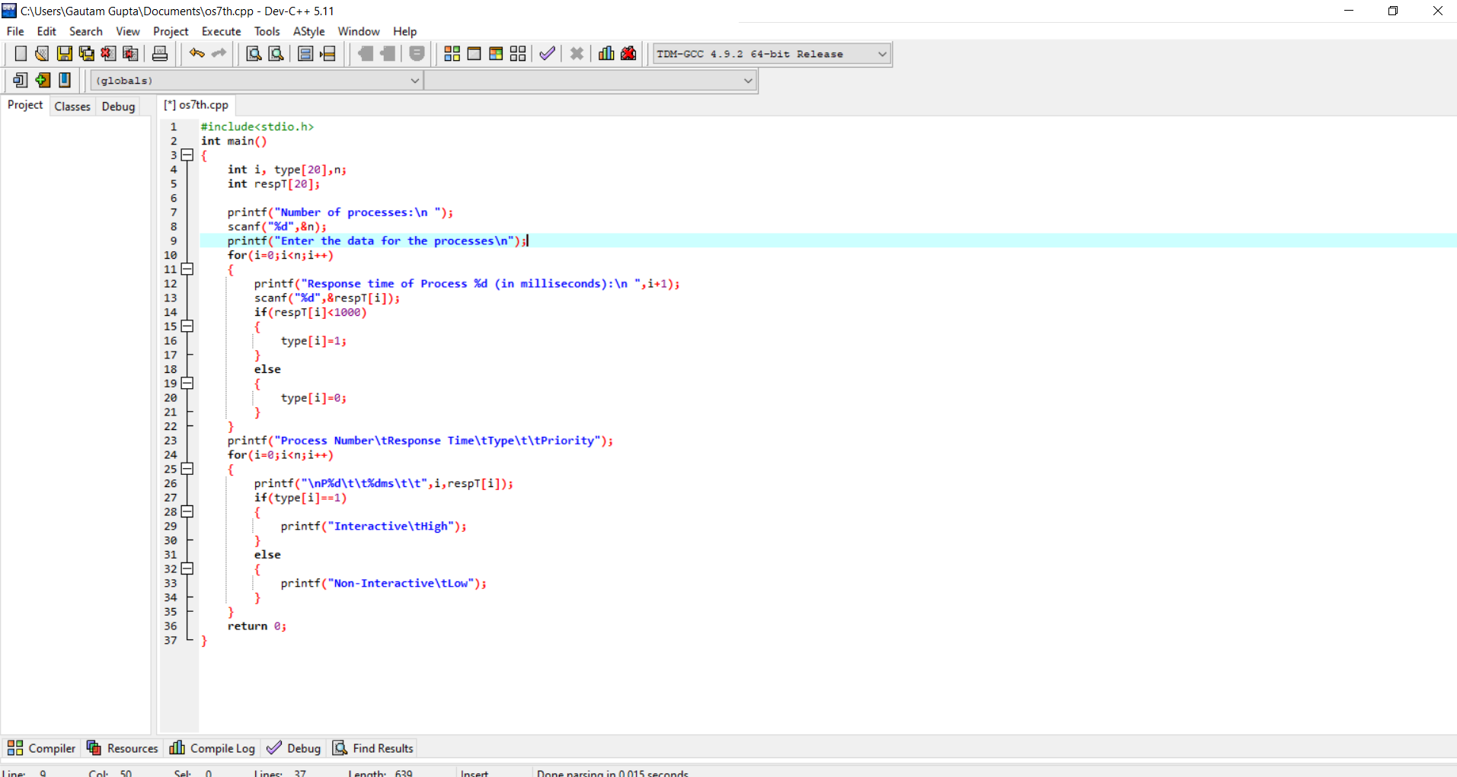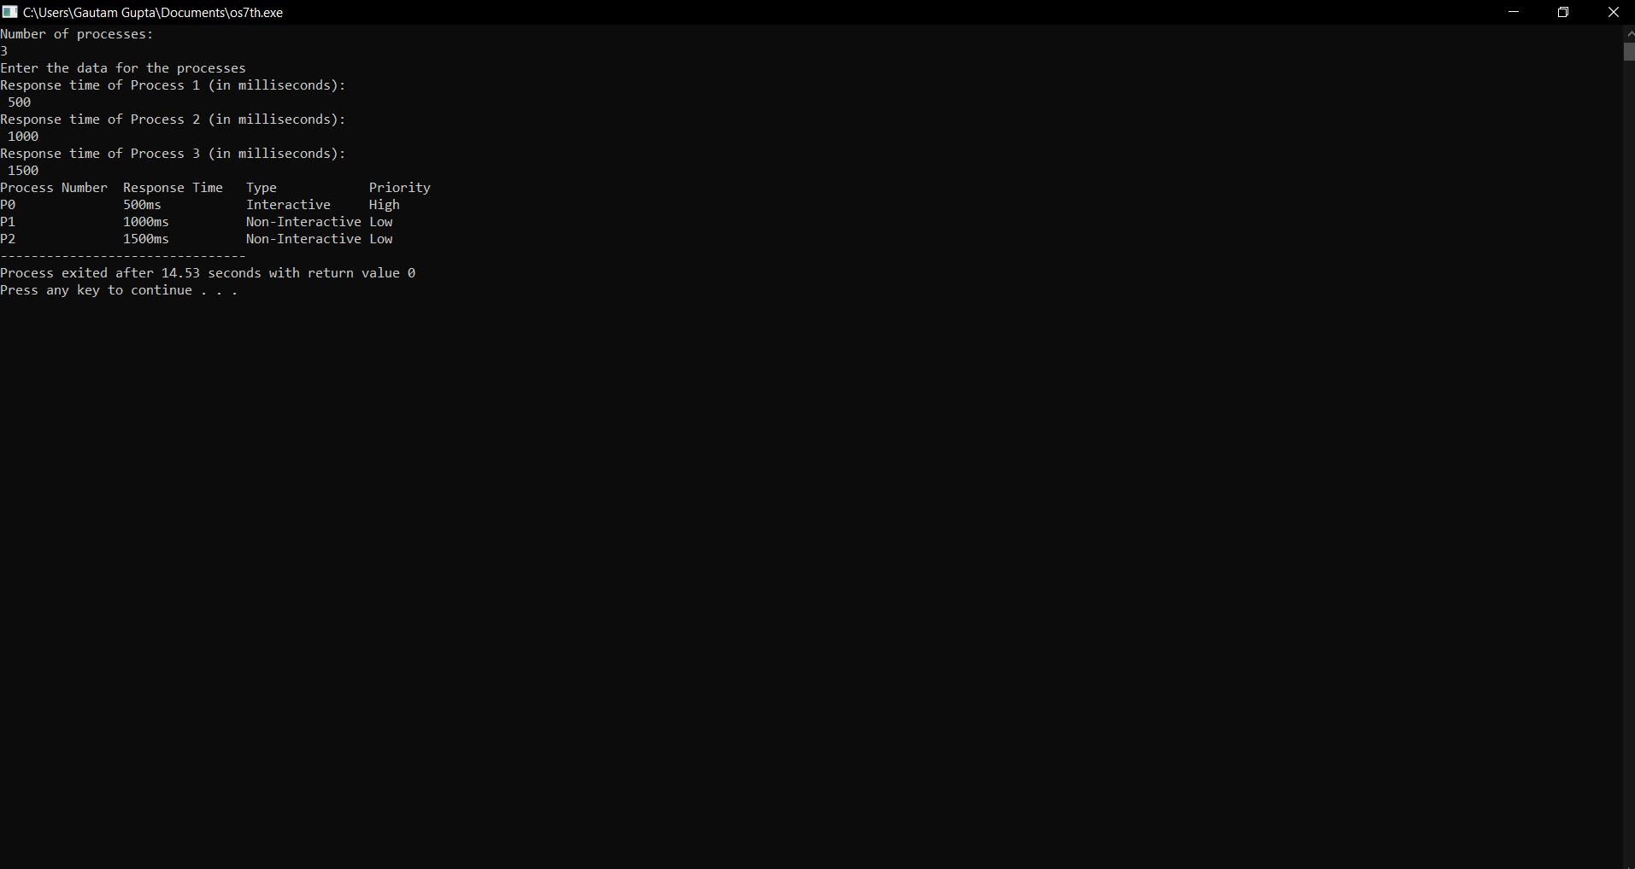
Problem:
There are 3 student processes and 1 teacher process. Students are supposed to do their assignments and they need 3 things for that pen, paper and question paper. The teacher has an infinite supply of all the three things. One students has pen,an other has paper and another has question paper. The teacher places two things on a shared table and the student having the third complementary thing makes the assignment and tells the teacher on completion. The teacher then places another two things out of the three and again the student having the third thing makes the assignment and tells the teacher on completion. This cycle continues. WAP to synchronize the teacher and the students.
Explanation:
- Firstly we provide each student with one thing that is pen , paper and question paper .
- Then we ask teacher for two items to be placed on shared table.
- Then the student with third item gets the other two items .
- This is how turn by turn everyone student achieve his/her requirement and cycle goes on.
Code Snippet:
#include<stdio.h>
#include<stdbool.h>
struct req
{
bool pen ;
bool paper ;
bool question_paper ;
bool all_three ;
};
int main()
{
int n=3;
struct req s[n];
s[0].pen=true;
s[0].paper = false;
s[0].question_paper = false;
s[0].all_three= false;
s[1].pen=false;
s[1].paper = true;
s[1].question_paper = false;
s[1].all_three = false;
s[2].pen=false;
s[2].paper = false;
s[2].question_paper = true;
s[2].all_three = false ;
while(s[0].all_three==false||s[1].all_three==false||s[2].all_three==false)
{
int ch1,ch2;
printf("\nResources:\n1.pen\n2.paper\n3.question paper\n Enter the two things which is to be placed on the shared table: ");
scanf("%d%d",&ch1,&ch2);
if(ch1==1 && ch2==2 && s[2].all_three==false)
{
s[2].all_three=true ;
printf("Third Student has completed the task\n");
}
if(ch1==2 && ch2==3 && s[0].all_three==false)
{
s[0].all_three=true;
printf("First Student has completed the task\n");
}
if(ch1==1 && ch2==3 && s[1].all_three==false)
{
s[1].all_three=true;
printf("Second Student has completed the task\n");
}
}
printf("All the students now have completed their respective tasks succesfully\n");
return 0;
}
